**HOME NETWORK TOPOLOGY:**

A typical home network topology diagram visually represents how devices in a home network are connected, typically using a star topology where each device connects to a central router. This diagram often includes devices like a modem, router, wired devices (computers, printers), and wireless devices (smartphones, tablets). The diagram helps visualize the flow of data and the relationships between network components.

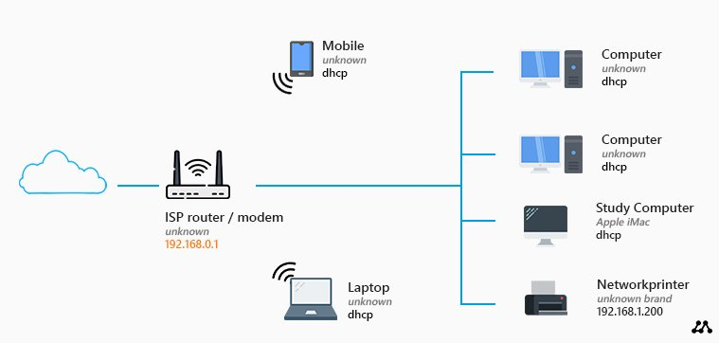

Key Components:

* **Modem:**

Connects the home network to the internet.

* **Router:**

A central device that distributes the internet connection and manages communication within the network.

* **Wired Devices:**

Computers, printers, or other devices connected directly to the router or a switch with Ethernet cables.

* **Wireless Devices:**

Smartphones, tablets, or other devices that connect to the network wirelessly via Wi-Fi.

Common Home Network Topologies:

* **Star Topology:**

The most common topology, where all devices connect to a central router or switch. This is a straightforward and reliable configuration for home networks.

* **Mesh Topology:**

Less common in homes, but offers more redundancy. Each device connects to multiple others, allowing data to find the shortest path.